Naish Bolt 2011  12.0 m | Naish Park 2011  9.0 + 12.0 | Naish Torch 2011  9.0 + 11.0
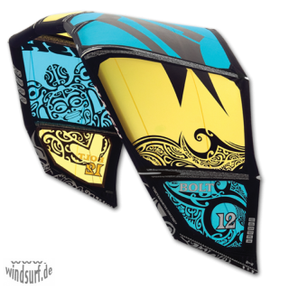 | 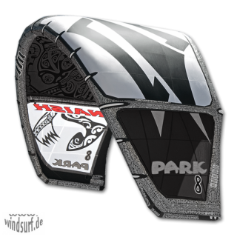 | 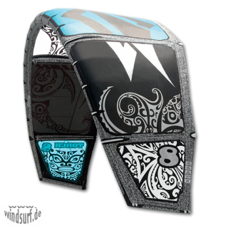
1149,- €  ab 834,- € | 979,- €  ab 709,- € | 1029,- €  ab 669,- €
Cabrinha Crossbow  2011 / 11.0 | Cabrinha Nomad  2011 / 9.0 + 11.0 | Cabrinha Convert  2011 / 7.0 + 9.0
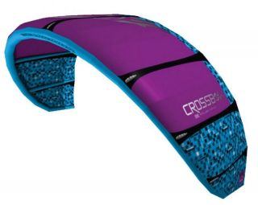 | 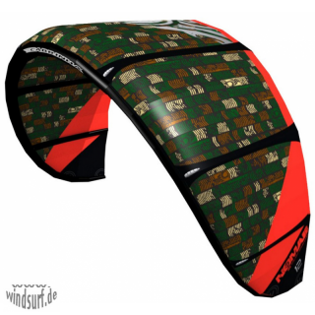 | 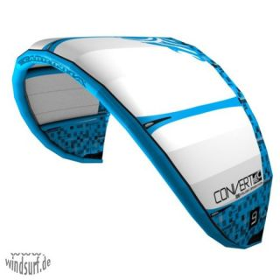
1416,- €  ab 879,- € | 916,- €  ab 759,- € | 866,- €  ab 579,- €

TOP OFFER:
F-One Bandit 4
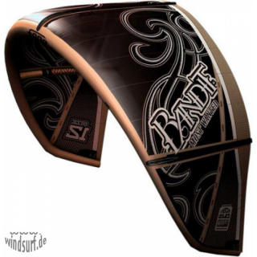
940,- €
ab 779,- €

Nobile T5 2011 | Nobile NHP 2011 | Nobile 50Fifty 2011
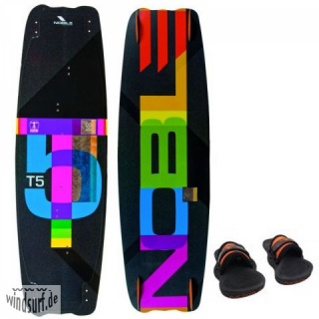 | 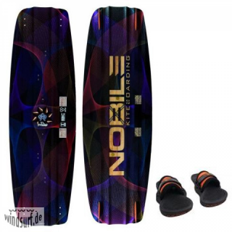 | 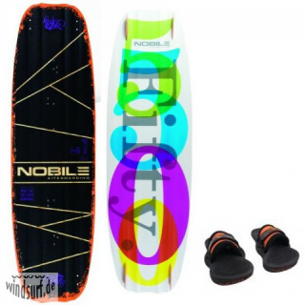
549,- €  479,- € | 659,- €  559,- € | 699,- €  559,- €
Wainman Joke 2011 | F-One Trax 6 2011 | Brunotti Youri Zoon Pro 2011
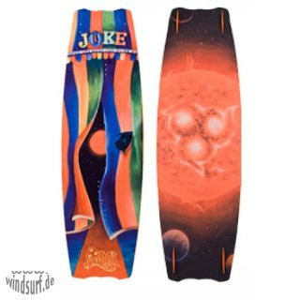 | 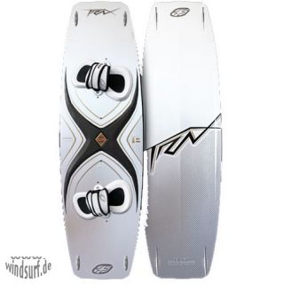 | 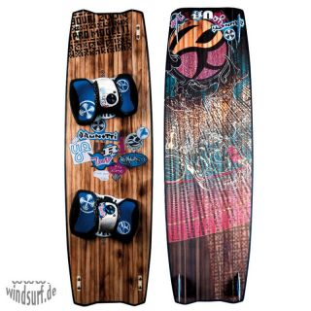
696,- €  529,- € | 749,- €  629,- € | 748,- €  529,- €

